FOR SALE
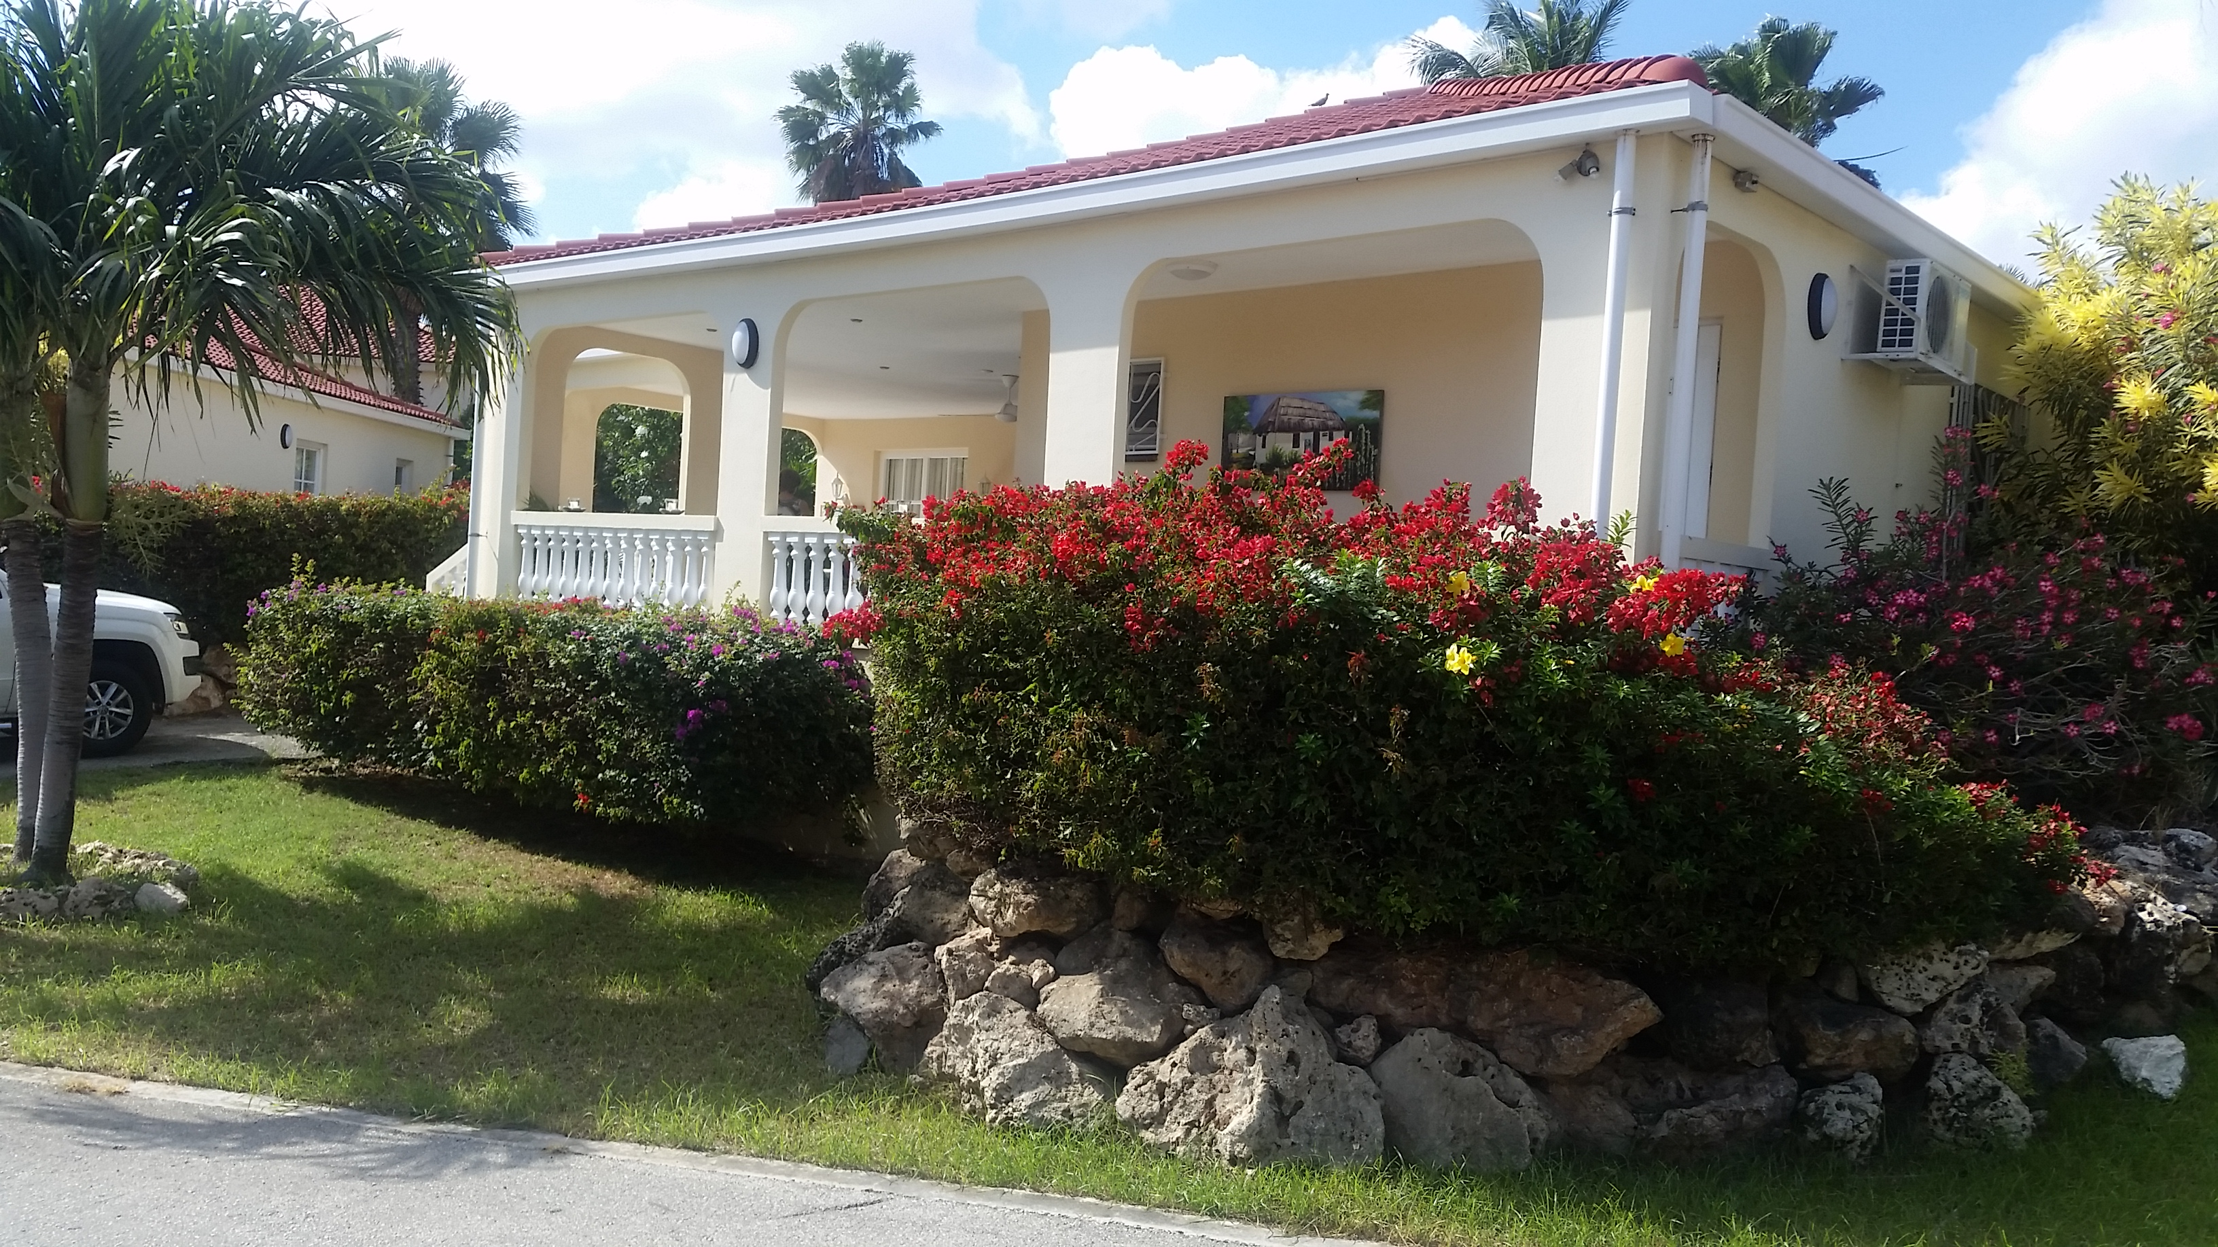
Lagun 19 at Livingstone Jan Thiel Resort

- 3 Bedrooms  - 2 Bathrooms  - Spacious living room  - Full kitchen  - Cable TV network  - Guest toilet  - Spacious terrace with hard wooden lounge set  - Laundry  - Private parking lot |  | The Lagun is the pride of Livingstone exotic resort. These villas are detached, comfortably furnished and equipped with all possible luxury. The villa features an unobstructed breathtaking view to the Caribbean Sea. There are two bedrooms, both with air conditioning and an en-suite bathroom. The villa has always been well maintained.  Livingstone is a beautiful resort where you nicely can relax. The colorful resort with apartments and villas is spacious with a tropical flower garden and a beautiful swimming pool. The resort has a perfect location. Near Livingstone you have the most famous beaches and supermarkets.  Price: € 245,000.- Buyers Cost  The price is inclusive inventory
